Technical & Financial Brochure
Pharmaceutical Marketing

I Practical & Cases Study

I 5 Days, 15 hrs. Virtual Training
18/08/2024
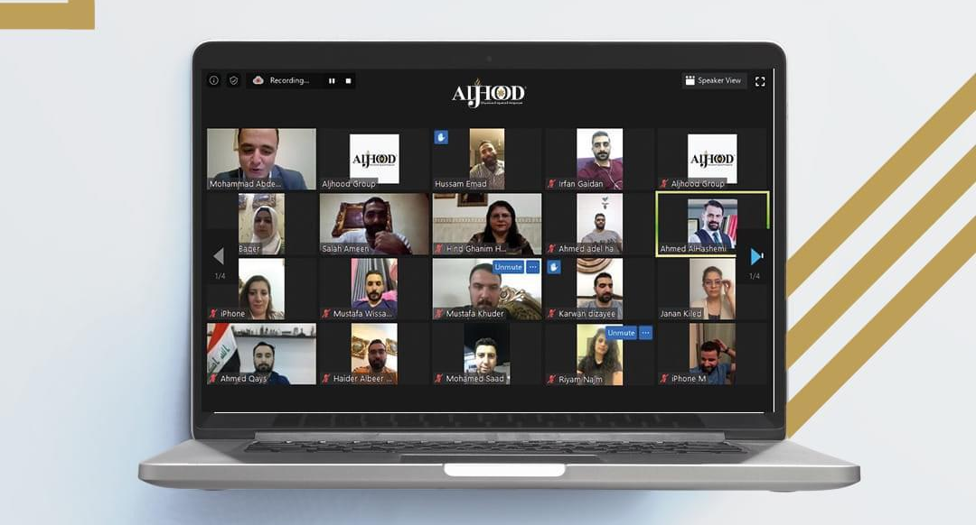

Course Card:

Course Title | : | Pharmaceutical Marketing
Training Period | : | (5) Days, (15) hrs.
Training Venue | : | Virtual “Distance Training”
Training Date | : | 18-22/08/2024
Training Methodology | : | - Brain Storming.  - Groups Discussion.  - Scenario-Lased Learning.  - Question and answer sessions.  - Cases study from environment.
Accreditation | : | - Electronic Attendance Certificate from Aljhood (90% Attendnce Is Must)
Target Audience | : | - Product Managers.  - Marketing Managers.  - Interested participants, and anyone you deem suitable.

Course Overview:

Pharmaceutical marketing is a complex and highly regulated field that presents unique challenges for companies in the sector. However, with effective strategies tailored to the needs of the audience, companies can promote their products and services ethically and successfully, Our course will cover a wide range of topics relevant to pharmaceutical marketing, including but not limited to:

- Brand Management: Developing effective branding strategies to differentiate products in the market and enhance brand equity.
- Marketing Plans: Going through marketing plan formulation in details by applying it on your company.
- Pharmaceutical printing promotional materials: Going through promotional printing materials in details through a case studies
- Digital Marketing in Pharmaceuticals: Leveraging digital channels and technologies to reach and engage healthcare professionals and consumers effectively.
- Market Research and Analysis: Conducting market research to identify trends, assess competition, and inform marketing strategies.
- Ethics and Professionalism: Promoting ethical marketing practices and maintaining professionalism in all interactions with stakeholders.

Course Objectives:
By the end of this training course, the participants will be able to achieve the following:
- Enhanced Marketing Competence:
Equip marketing teams with the knowledge and skills necessary to develop and execute effective pharmaceutical marketing campaigns.
- Compliance Assurance:
Ensure adherence to regulatory requirements and mitigate the risk of non-compliance through comprehensive training on pharmaceutical marketing regulations.
- Improved Brand Performance:
Optimize brand performance and market share through strategic brand management and targeted marketing initiatives.
- Increased Efficiency and Productivity:
Empower employees with the tools and techniques to work more efficiently and productively in their marketing roles.
- Competitive Advantage:
Gain a competitive edge in the pharmaceutical market by staying ahead of industry trends and adopting innovative marketing strategies.

Course Modules:

MODULE “1”: Marketing Management Overview
- Introduction to Marketing Management.
- The Value of Marketing in Business.
- The Scope of Marketing: Understanding Pharmaceutical Market Dynamics.
- Marketing Management Process: Planning, Implementation, and Control.
- Targeting Strategies: Identifying and Attracting the Right Audience.
- Group Discussion on Targeting Strategies.

MODULE “2”: Marketing Mix
- Overview of Marketing Mix
- Product Strategy: Developing and Positioning Products.
- Place Strategy: Distribution Channels and Logistics.
- Promotion Strategy: Advertising, Public Relations, and Sales Promotion.
- Personal Selling: Importance and Techniques.
- Case Study Selection: Analyzing Real-world Pharmaceutical Marketing Challenges.
- Group Discussion on Selected Case Studies.

MODULE “3”: Marketing Plans
- Understanding the Importance of Marketing Plans.
- Marketing Plan Template: Components and Structure.
- Marketing Plan Presentation: Developing Effective Presentations.
- Marketing Plan Discussion: Feedback and Peer Review.

MODULE “4”: Pharmaceutical Promotional Printing Materials
- Importance of Promotional Materials in the Pharmaceutical Industry.
- Promotional Materials Workshop: Design and Content Creation.
- Promotional Materials Presentation: Showcasing Workshop Outputs.
- Critique and Feedback Session on Promotional Materials.

